**MESD LMS Documentation – View/print/download general reports**

To facilitate with viewing/printing/downloading general reports.

**Background**

This module handles requests directly from a Head of Department to view, print or download general reports.

**Usage**

**View general reports**

1. Login as a Head of Department.
2. Go to *‘My courses’* then select a course.
3. Choose *‘Reports’*.
4. There are different options for Reports in the Reports page.

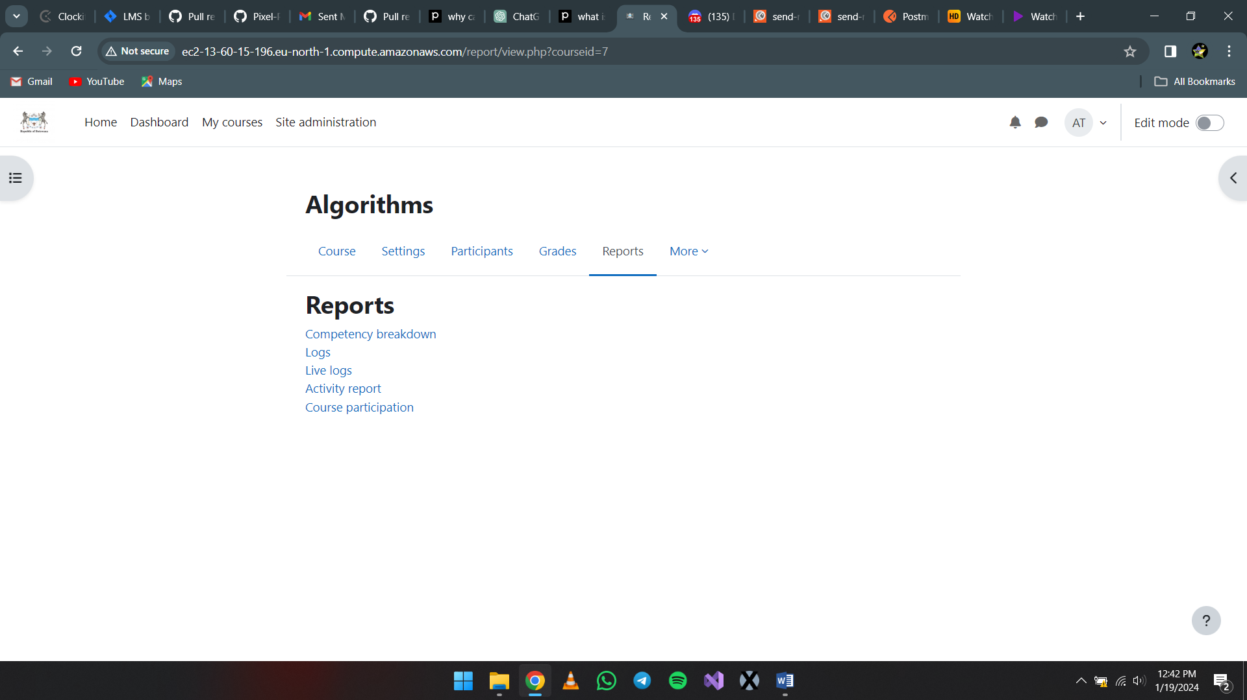

* 1. Competency breakdown: For each competency, it shows whether the student has achieved it or not.
     1. Select the student along with the options available to view each student’s competency in each assignment or quiz.

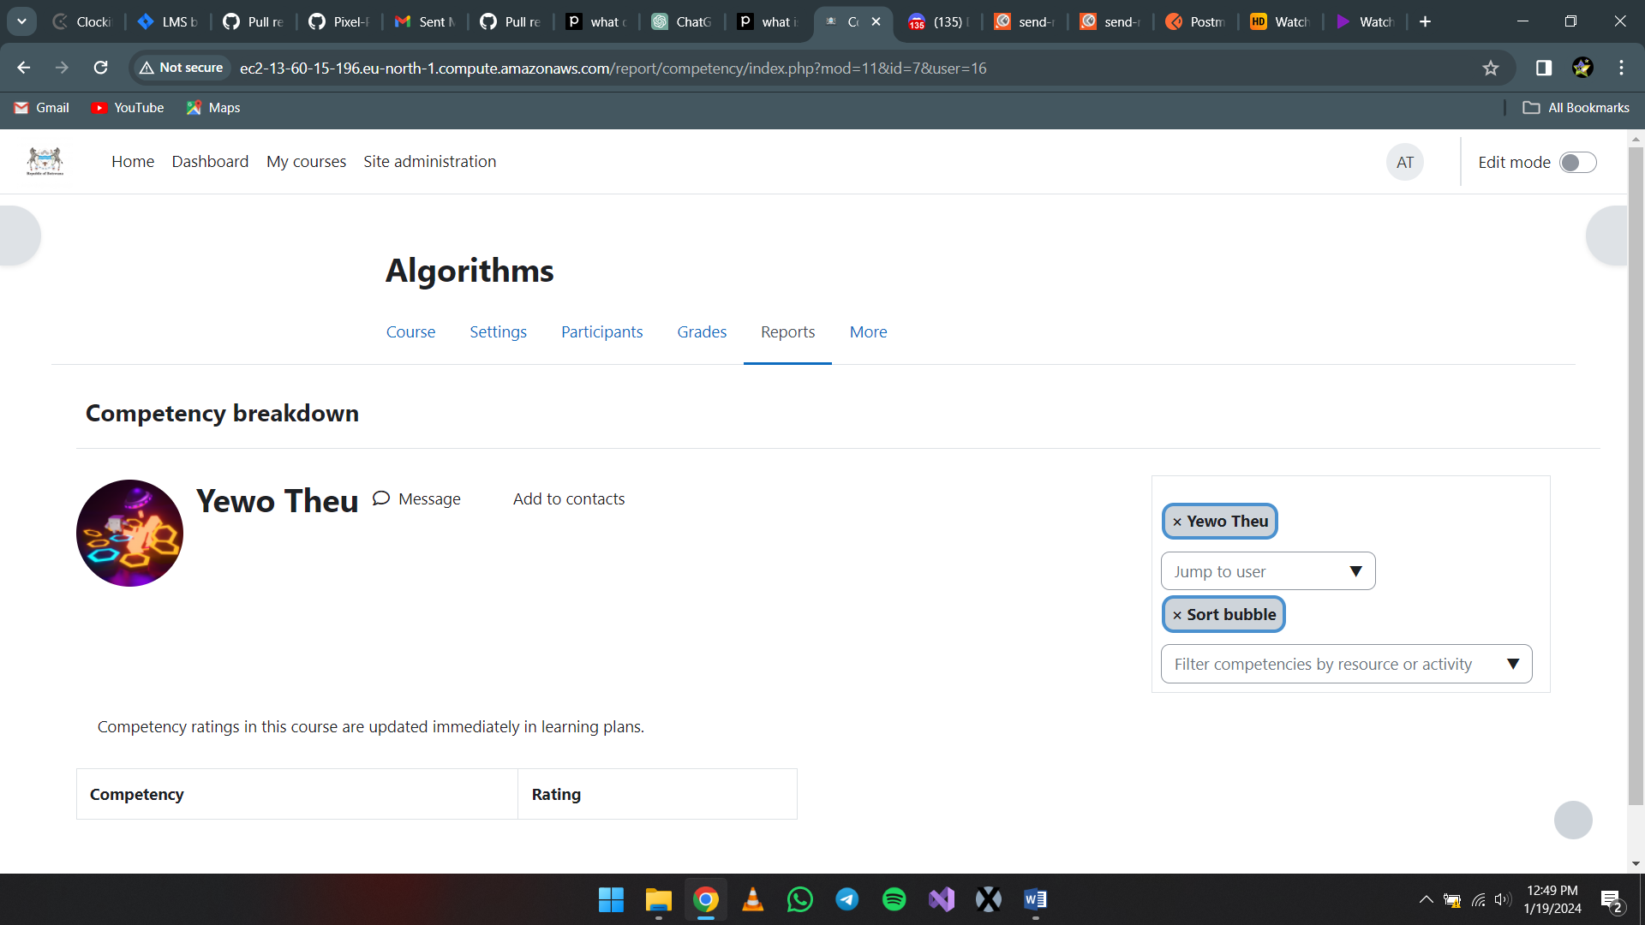

1. Select the resource or activity here.
2. Select the learner
   1. Logs: They offer insights into when and what resources or activities have been accessed, and by whom.
      1. Once you have entered this page you will get multiple options to help you filter and get logs for different courses and participants.

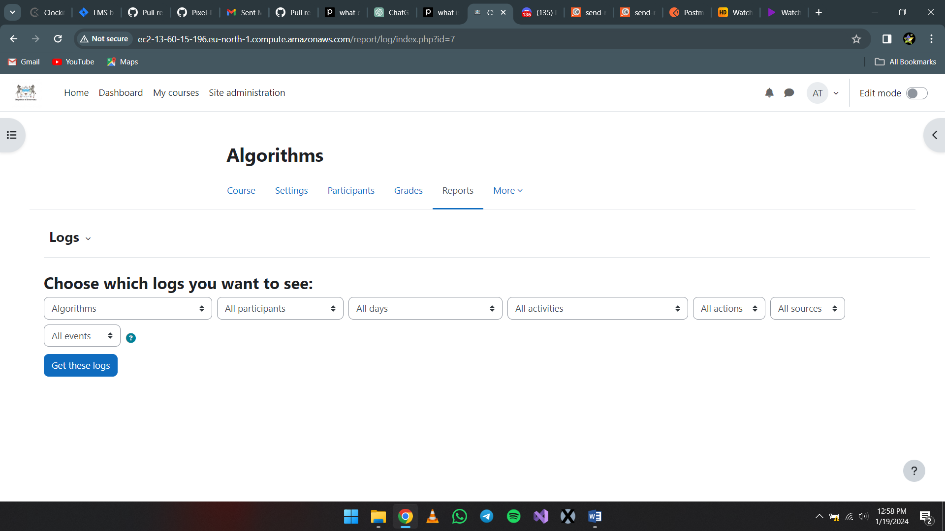

* + 1. Once done select *‘Get these logs’* to view the logs report of your selection.
  1. Live logs: Live logs in Moodle are real-time activity reports. They provide updates on user activity within a course or across the entire site, giving you a snapshot of what's happening at any given moment.
  2. Activity Report: This is a simple report with no filters that shows all activity in the course. It lists all the activities in the course along with the number of times each activity has been viewed and the date it was last viewed.
  3. Course Participation: provides an easy way to monitor general participation in your course. It is particularly useful for tracking activity in forums and other modules.
     1. Use the filter to choose the activity module, how far back (in days), which role and which action to show between viewing and posting that has been done by those users or user.

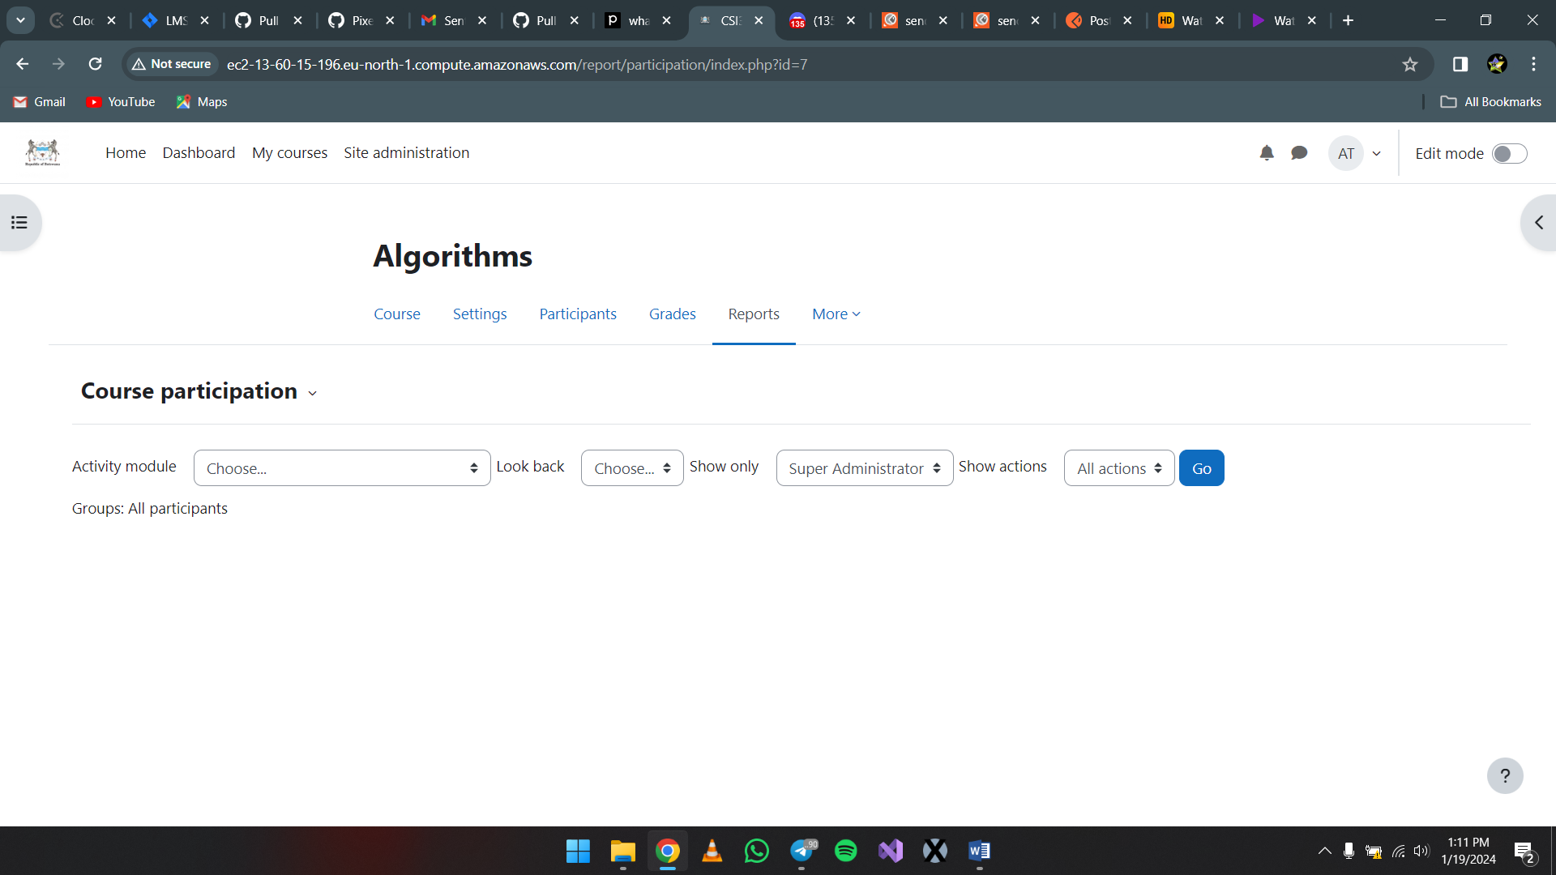

* + 1. Once done select *‘Go’* to view that report.

**Print/Download**

1. Log in as a Head of Department.
2. Select a report as shown above.
3. Once a specific report is being viewed, on your keyboard click CTRL + P to get the option to either print or download the page as a pdf file.